16.02.2020, WillCodeForFood

Project Proposal: Fire escape simulation

**Introduction**

Emin Thaqi is the representative of SIM Software Inc. SIM Software would like to extend its expertise to cover a broader area of simulation software. So the company has asked for a project proposal in the area of simulation software.

**Objectives**

The simulation provides the means to optimize the placement of fire extinguishers via statistics related to how many people reacted in the simulation.

**Scope**

The project will result in a working application, which runs simulations based on user input. The goal of the application is to determine the most effective placement of fire extinguishers for a given floor plan and number of people.

**Timeframe**

|  |  |  |
| --- | --- | --- |
|  | Deliverables | Start and End Dates |
| Kick-off phase | * Project plan * Proposal | Week 1-2 |
| Initial phase | * URS * Work division report * Iteration 1 planning | Week 3-4 |
| Iteration One | * Updated URS * Working application * Updated Work division report * Iteration 2 planning | Week 5-9 |
| Calibration session | * Progress presentation | Week 10 |
| Iteration Two | * Updated URS * Updated Design document * Working application * Unit tests * Updated Work division report * Iteration 3 planning | Week 11-13 |
| Iteration Three | * Updated URS * Updated Design document * Test report * Working application * Unit tests | Week 14-16 |
| End phase | * Process report * Final presentation | Week 17-18 |

**Key Stakeholders**

|  |  |
| --- | --- |
| Client | Emin Thaqi |
| Project manager | Chandieka Tasbihyantra |

**Monitoring and Evaluation**

To assure the quality of the end product we will have weekly meetings with the mentor/client in order to keep track of our progress and make adjustments based on the given feedback.

**Solutions**

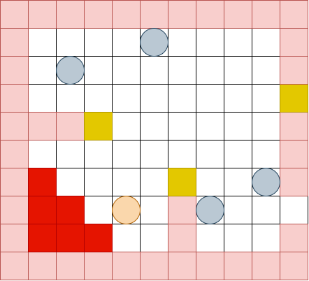

Explanation:

People, fire, and fire extinguishers will be represented by a certain color. People will move to the closest fire extinguisher when a fire starts, it will then go to the fire to extinguish it. If a person with a fire extinguisher reaches the fire or all people have died, the simulation stops. At the end of the simulation, the number of people with fire extinguishers gets subtracted from the number of people that died; this information gets saved along with the execution time (animation ticks).